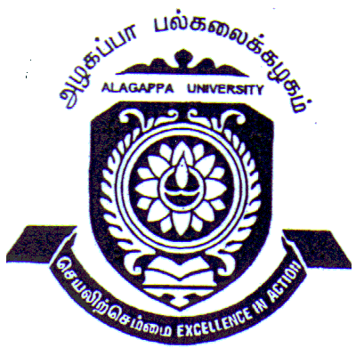
DEPARTMENT OF WOMEN’S STUDIES
ALAGAPPA UNIVERSITY, KARAIKUDI-630 003
(Accredited with ‘A’ Grade by NAAC) Ph: 04565-224615
Fax: 04565-225202
Email: au_cwskkdi@yahoo.co.in

Dr. K. MANIMEKALAI Date: 12.07.11

Head i/c

Applications are invited for the engagement of Teaching Assistant on temporary basis to handle the Master of Social Work course subjects in the Department of Women’s Studies for the period of six months.

Qualification - PG in Master of Social Work
preference will be given to M.Phil
candidates with teaching and Research experience.

Salary - Rs. 8000 /-per month (Consolidated)

Application should reach the Head i/c Department of Women’s Studies, Alagappa University, Karaikudi on or before 22nd July 2011 from the date of this advertisement.

